Final Report

Name: Charles Taggart
Course / Cohort: FSDI 110 / CH 65
Assignment: 111 Final Report
GitHub Repository Link: https://github.com/chucktagg83/FSDI-111_backend.git

Evidence of Functionality
Frontend/UI
Backend/Logic:

HTML Templates
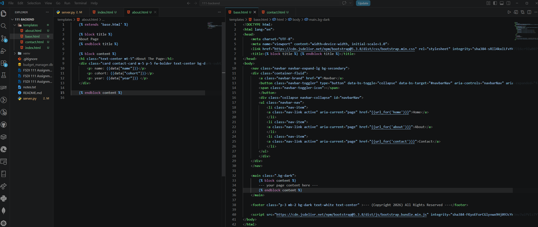
Sample Page rendered:
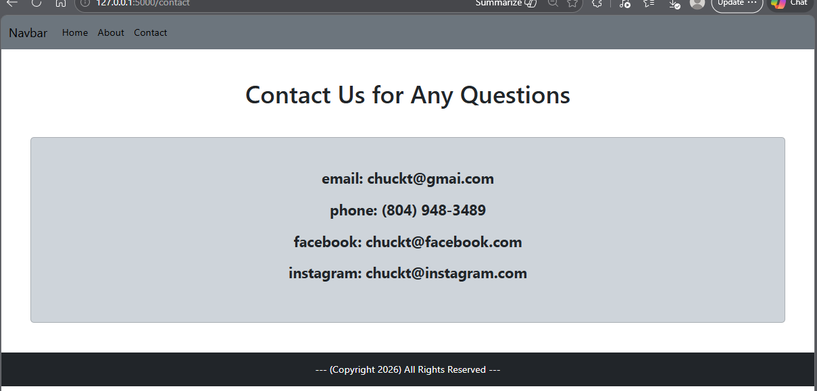

Retrospective
1.Which part of the project was the most difficult or challenging for you, and why?
This project itself was not very difficult. What was difficult was going back to some of the previous items learned, like adding in CSS (I forgot a lot of how to use bootstrap or how to make the items work), adding in javascript principles (still struggling to learn). I feel comfortable with the topics while we are doing them, but ultimately, I don’t feel that I have a strong baseline knowledge on any one topic yet, and its always a struggle trying to harken back to a previous subject.
2. What did you enjoy the most or learn the most from while working on this project, and why? This project seems like a great way build a site, where everything can be concise and straightforward in the coding, but I think a lot of practice and understanding would have to go into learning this process and all of its steps.

AI Disclosure (Required) – Highlight the one that applies
- I did not use AI
- I used AI for help
- AI generated parts of my code (if it’s the case, provide an explanation of the code in your own words).

